The Pandemic Pain is More Serious in Emerging Markets and Developing Countries: Causes and Remedies.
The Coronavirus has been a global pandemic that has negatively affected the economy of countries across the world. Most of the effects have been felt by the emerging markets and developing economies in the sub-Saharan countries. However, some of the Eastern European emerging markets like Moldova, Poland, Romania and Serbia have also been deeply hit by the pandemic. The impact has not only affected developing economies but also some of the developed countries like the United Kingdom that experienced a sharp decline in its GDP. As a result, most of the countries have experienced increased unemployment, reduction in working hours, temporary layoffs and discouragements in job search that has led to the staggering economy. There are possibilities that these economies can be restructured but still, both the indirect and direct financial costs are enormous. During this particular time, savings is one of the instruments to be used by people across the world as part of financial security. State governments, central banks as well as commercial banks use the same formular to shape their spending.
At the onset of the pandemic, most predictions looked at developing economies as areas that will record high death rates. The assumption was that most of these developing economies have inadequate resources in health sector like fewer hospital beds, inadequate medical equipment and health workers to fight the diseases. Surprisingly, the death rates have been very high in developed economies like the United states and Europe than in EMDEs. Some of the reasons why Latin America has been hit hard by the coronavirus includes the inequality gap, existence of many informal sectors, large population in the cities, increasing rate of internal migration and inadequate public health system. Additionally, Latin America has less experience in the inversion of deadly viruses when compared to Africa and East Asia where people have experienced Ebola and SARS. It is perceived that people from those regions have been cautious about the consequences of deadly viruses and they have been taking respective measures like maintaining social distance to save their lives.
Coronavirus has affected the financial markets and the world economy by interfering with businesses and organizational activities. It has negatively affected income as a result of low productivity, remote working and premature deaths. Although it’s an impact that shakes the global economy but EMDEs are greatly affected. Due to staggering economic activities, most of the EMDEs took loans to be used to fight the pandemic. But, even before the onset of the pandemic most of the EMDEs countries had debts and others had few chances to undertake discretionary fiscal policies. This is an economic situation that can easily send EMDEs countries into a default state. The projection shows that in 2021, the EMDEs fiscal deficits are likely to double to almost 10.5% of their GDP averagely than in 2019. Also, government debt is predicted to cover up to 63% of the total GDP increasing with over 10% from 2019.
In terms of external debts, EMDEs have over $11 trillion in external debt and approximately $3.9 trillion as in debt service. The pandemic has created a global health emergency plan and its likely that the unconditional increase in debt can also create a global development emergency plan. This situation invites a high risk of insolvency that cannot be controlled by raising an alarm on risks of cooperate default. To reduce the dilemma of both international and internal debts of EMDEs countries, there must be a technique to be used to write off their interest payments in the coming years. Alternatively, since, these countries need extra support, IMF should also come in hand and expand the credit lines of these countries. For example, Colombia asked for an increase. The increase in public debt and pressure created by coronavirus pandemic in emerging markets and developing countries has created a long run crisis especially in the health sector. After all, there are high chances that other more focus is placed on coronavirus therefore underfunding other crucial health welfare programmes. EMDEs countries have inadequate health resources and there are also many other diseases which are not related to the pandemic but they are killing more people. As a result, government attention is on the pandemic and channells almost all of its funds located for health system in treating covid 19 neglecting other diseases such as tuberculosis Malaria and HIV/AIDS. In 2020, almost 40m children were not vaccinated in Parkistan. In the long run, this is crucial because if cutting funds continues even other welfare like free maternity will be highly affected.
From the graph below, we can see that government debts in EMDEs have dramatically increased due to fiscal stimulus packages. Even if the fiscal stimulus is eliminated EMDEs country’s fiscal condition is worse due to a steady decline in revenue from a staggering economy. The research done by consultancy oxford Economics shows that if the situation continues as per the way, it is then, Mexico’s government debt is likely to rise by over 11% of the GDP by 2021. On the other side, India is also expected to increase her by 8.7 % (fig 1). Country’s such as Thailand, Poland, chile and Brazil declared larger stimulus debt packages and this means that they receive large debt gains in return. However, higher rate of government borrowing means there is impetus that stimulate private sector development that seeks extra financial support to cover internal costs during the pandemic. Higher borrowing costs will also come at the expense of business investment, which will weigh on productivity and longer-term economic growth.

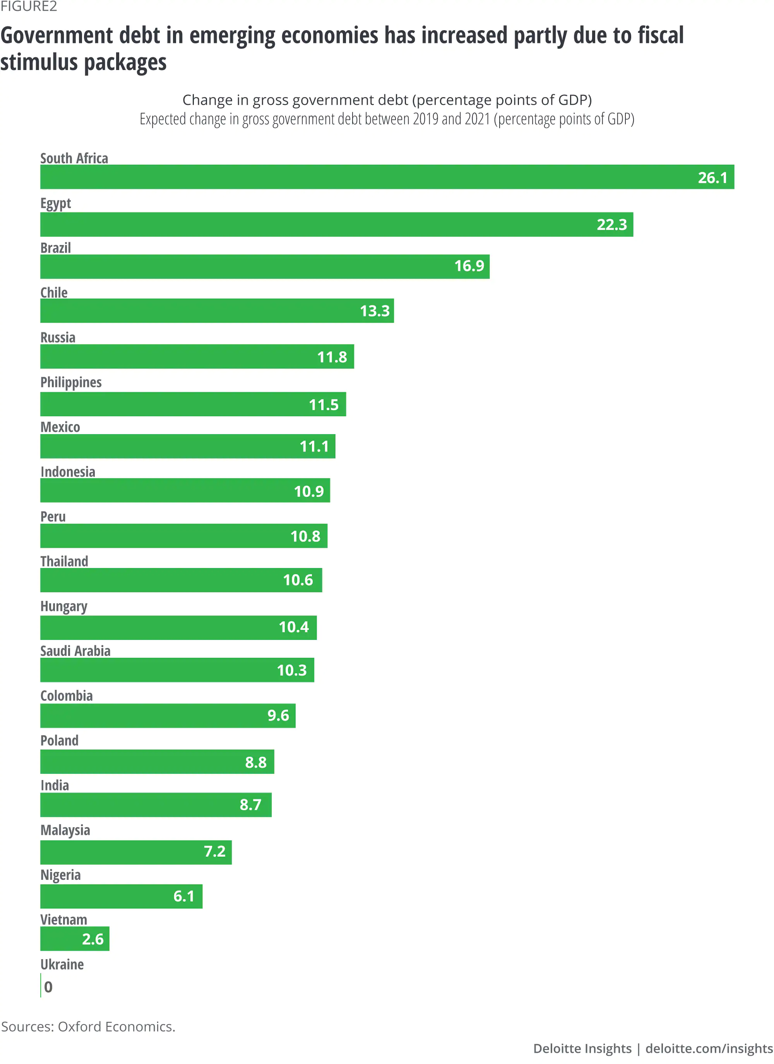

Exchange rate market in EMDEs
Advanced economies provided policy support to EMDEs economy policymakers on ways of sustaining the economic blow. Most of the emerging markets economies tightened their policies to prevent capital outflow to avoid inflation as a result of depreciation in the exchange rate but as a result of the pandemic, they have adapted policy equivalent to developed economies. Most of the emerging market economies uses reserve barriers and they allow adjustment to exchange rate. In many cases, most of the countries inject liquidity to facilitate their market activities, for example, countries like Poland and Indonesia further eased some policies to support credit.
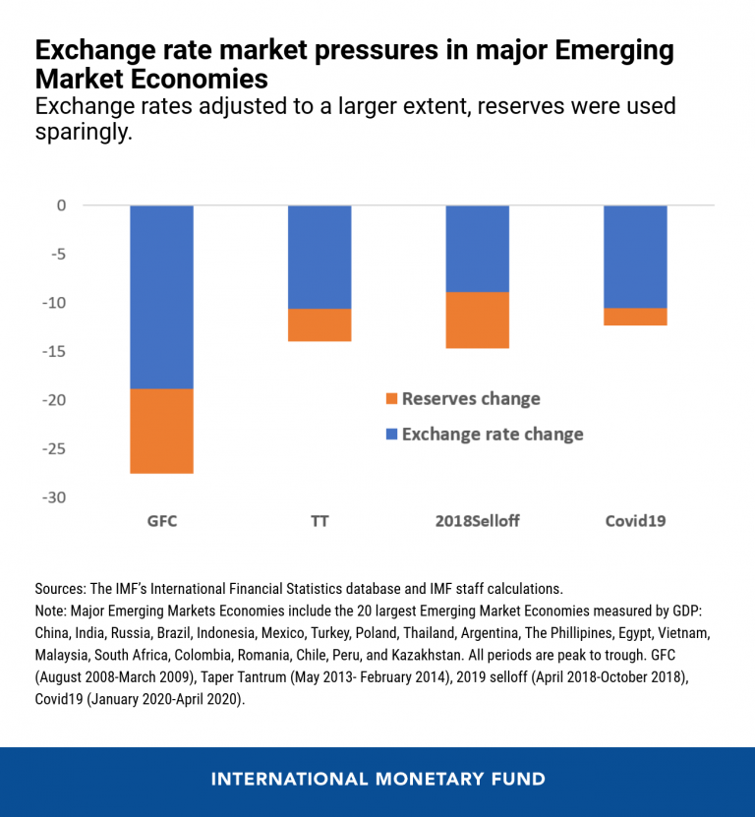
Government measures such as imposing lockdowns as a means of combating the spread of the virus have caused total disturbances in the supply chain and closure of factories. For instance, China is one of the EMDEs and the restrictions imposed such as lockdowns greatly influenced the production and manufacturing sector. Another sector that has been affected is the service industry like hospitality, transportation and tourism as they have experienced losses due to travel bans. Other policies such as self-isolation and quarantine led to massive reduction in the level of consumption thus reducing the demand for goods and services. This is because consumers were forced to change their spending habit due to low income and household. Also, most of the people fear about the nature of this pandemic because its unpredictable therefore, they save more than spending.
The Role of External Demand Shocks under no Lockdown
In this scenario we look at the Turkish demand factor. A reduction in demand for foreign goods creates a total decline in output of domestic sector. The graph below shows three scenarios, and the first scenario expresses the demand shock in the global condition. For instances, if a reflection from the Turkish data presents a decline in automobiles by a certain percentage, then it means there is a global decline for demand in automobiles across the world and more so, EMDEs. Also, the graph shows the change in total output, exports and imports during the pandemic for both scenarios. The total output is reduced by 19.8% in the first scenario. The exports declined by 23.4%, this was 5.5 more from the declined experienced in the imports which was 17.9%. This situation is more consistent with EMDEs countries because most of them depend on importing intermediate goods. Therefore, demand plays a critical role in the economic total costs, if foreign demand reduces then aggregate output also reduces.

